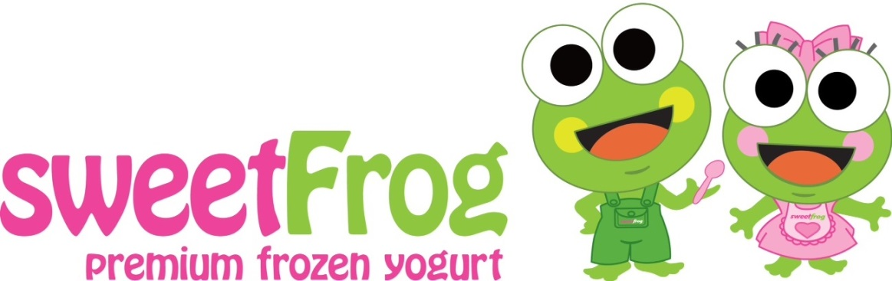

Cornelius Elementary faculty, staff, families…

For our business we want your business

In the months of October through December 2013…

Show your school ID (or mention CES) and receive a 25% discount at our
Cornelius location only

and

On the first Friday of the month
“Buy One Get One” FREE

Cornelius Sweet Frog
20545-D Torrence Chapel Road
Cornelius, NC 28031

704-896-7760

